**Solved Questions on Disk Scheduling**

**Problem-01:**

Consider a disk queue with requests for I/O to blocks on cylinders 98, 183, 41, 122, 14, 124, 65, 67. The SSTF scheduling algorithm is used. The head is initially at cylinder number 53 moving towards larger cylinder numbers on its servicing pass. The cylinders are numbered from 0 to 199. The total head movement (in number of cylinders) incurred while servicing these requests is _______.

**Solution-**

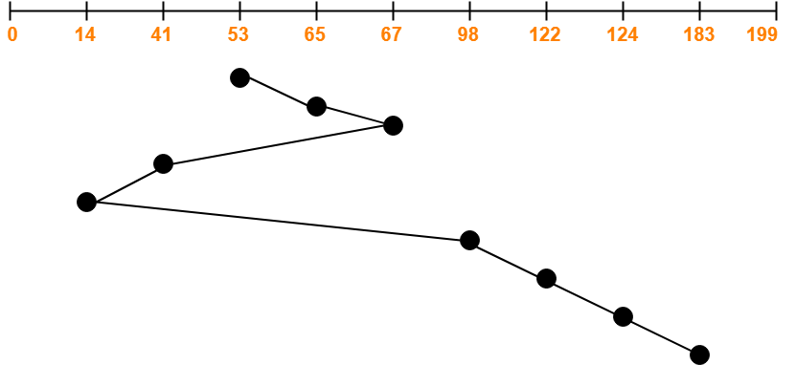

Total head movements incurred while servicing these requests

= (65 – 53) + (67 – 65) + (67 – 41) + (41 – 14) + (98 – 14) + (122 – 98) + (124 – 122) + (183 – 124)

= 12 + 2 + 26 + 27 + 84 + 24 + 2 + 59

= 236

**Problem-02:**

Consider a disk system with 100 cylinders. The requests to access the cylinders occur in following sequence-

4, 34, 10, 7, 19, 73, 2, 15, 6, 20

Assuming that the head is currently at cylinder 50, what is the time taken to satisfy all requests if it takes 1 ms to move from one cylinder to adjacent one and shortest seek time first policy is used?

1. 95 ms
2. 119 ms
3. 233 ms
4. 276 ms

**Solution-**

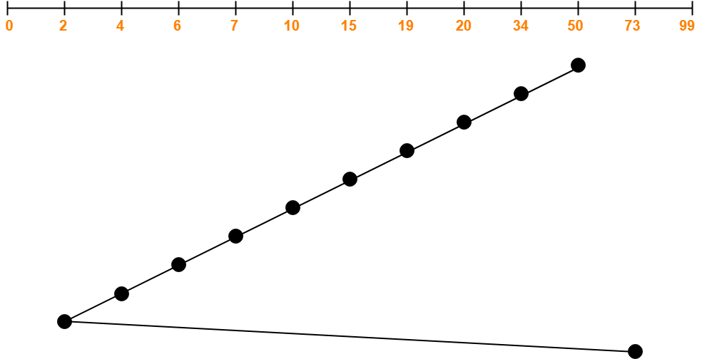

Total head movements incurred while servicing these requests

= (50 – 34) + (34 – 20) + (20 – 19) + (19 – 15) + (15 – 10) + (10 – 7) + (7 – 6) + (6 – 4) + (4 – 2) + (73 – 2)

= 16 + 14 + 1 + 4 + 5 + 3 + 1 + 2 + 2 + 71

= 119

Time taken for one head movement = 1 msec. So,

Time taken for 119 head movements

= 119 x 1 msec

= 119 msec

## ****Problem-****

Consider a disk queue with requests for I/O to blocks on cylinders 98, 183, 41, 122, 14, 124, 65, 67. The SCAN scheduling algorithm is used. The head is initially at cylinder number 53 moving towards larger cylinder numbers on its servicing pass. The cylinders are numbered from 0 to 199. The total head movement (in number of cylinders) incurred while servicing these requests is _______.

## ****Solution-****

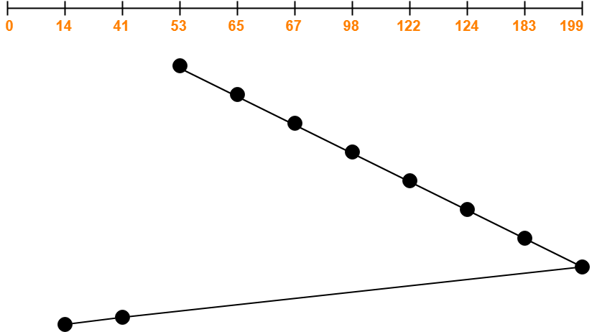

Total head movements incurred while servicing these requests

= (65 – 53) + (67 – 65) + (98 – 67) + (122 – 98) + (124 – 122) + (183 – 124) + (199 – 183) + (199 – 41) + (41 – 14)

= 12 + 2 + 31 + 24 + 2 + 59 + 16 + 158 + 27

= 331

**Alternatively**,

Total head movements incurred while servicing these requests

= (199 – 53) + (199 – 14)

= 146 + 185

= 331

## ****Problem-****

Consider a disk queue with requests for I/O to blocks on cylinders 98, 183, 41, 122, 14, 124, 65, 67. The C-SCAN scheduling algorithm is used. The head is initially at cylinder number 53 moving towards larger cylinder numbers on its servicing pass. The cylinders are numbered from 0 to 199. The total head movement (in number of cylinders) incurred while servicing these requests is _______.

## ****Solution-****

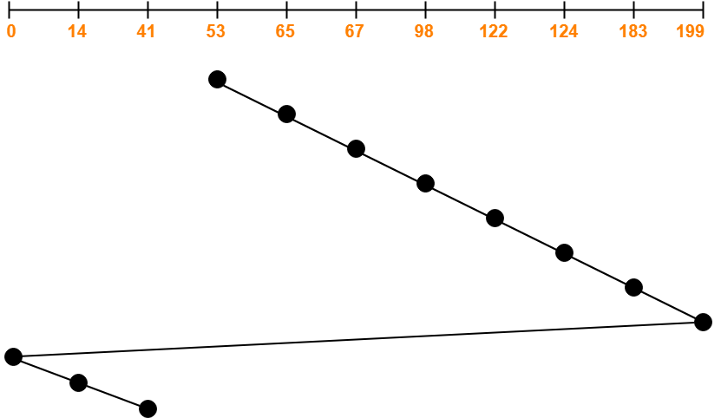

Total head movements incurred while servicing these requests

= (65 – 53) + (67 – 65) + (98 – 67) + (122 – 98) + (124 – 122) + (183 – 124) + (199 – 183) + (199 – 0) + (14 – 0) + (41 – 14)

= 12 + 2 + 31 + 24 + 2 + 59 + 16 + 199 + 14 + 27

= 386

**Alternatively**,

Total head movements incurred while servicing these requests

= (199 – 53) + (199 – 0) + (41 – 0)

= 146 + 199 + 41

= 386

## ****Problem-****

Consider a disk queue with requests for I/O to blocks on cylinders 98, 183, 41, 122, 14, 124, 65, 67. The LOOK scheduling algorithm is used. The head is initially at cylinder number 53 moving towards larger cylinder numbers on its servicing pass. The cylinders are numbered from 0 to 199. The total head movement (in number of cylinders) incurred while servicing these requests is _______.

## ****Solution-****

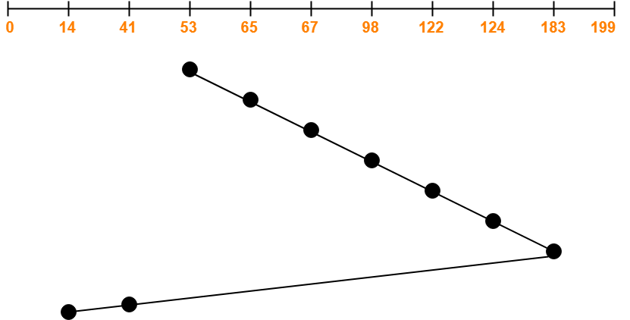

Total head movements incurred while servicing these requests

= (65 – 53) + (67 – 65) + (98 – 67) + (122 – 98) + (124 – 122) + (183 – 124) + (183 – 41) + (41 – 14)

= 12 + 2 + 31 + 24 + 2 + 59 + 142 + 27

= 299

## ****Problem-01:****

Consider a disk queue with requests for I/O to blocks on cylinders 98, 183, 41, 122, 14, 124, 65, 67. The C-LOOK scheduling algorithm is used. The head is initially at cylinder number 53 moving towards larger cylinder numbers on its servicing pass. The cylinders are numbered from 0 to 199. The total head movement (in number of cylinders) incurred while servicing these requests is _______.

## ****Solution-****

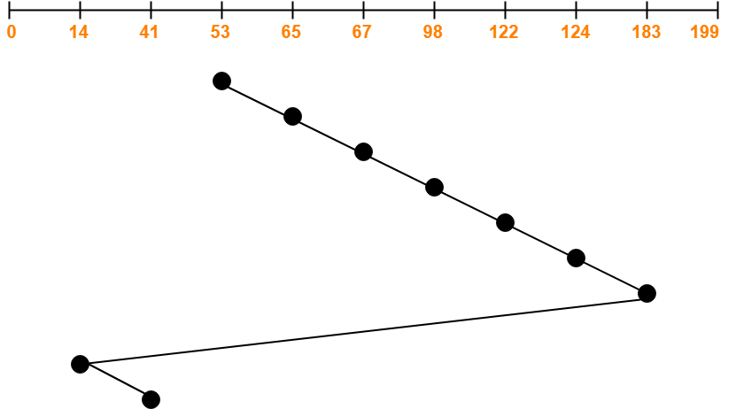

Total head movements incurred while servicing these requests

= (65 – 53) + (67 – 65) + (98 – 67) + (122 – 98) + (124 – 122) + (183 – 124) + (183 – 14) + (41 – 14)

= 12 + 2 + 31 + 24 + 2 + 59 + 169 + 27

= 326

**Alternatively**,

Total head movements incurred while servicing these requests

= (183 – 53) + (183 – 14) + (41 – 14)

= 130 + 169 + 27

= 326

## ****Problem-02:****

Consider a disk queue with requests for I/O to blocks on cylinders 47, 38, 121, 191, 87, 11, 92, 10. The C-LOOK scheduling algorithm is used. The head is initially at cylinder number 63 moving towards larger cylinder numbers on its servicing pass. The cylinders are numbered from 0 to 199. The total head movement (in number of cylinders) incurred while servicing these requests is _______.

## ****Solution-****

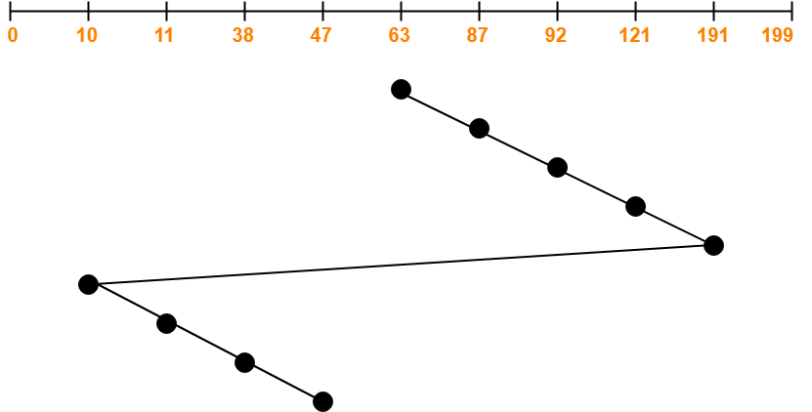

Total head movements incurred while servicing these requests

= (87 – 63) + (92 – 87) + (121 – 92) + (191 – 121) + (191 – 10) + (11 – 10) + (38 – 11) + (47 – 38)

= 24 + 5 + 29 + 70 + 181 + 1 + 27 + 9

= 346

**Alternatively**,

Total head movements incurred while servicing these requests

= (191 – 63) + (191 – 10) + (47 – 10)

= 128 + 181 + 37

= 346

## ****Problem-****

Consider a disk queue with requests for I/O to blocks on cylinders 98, 183, 41, 122, 14, 124, 65, 67. The FCFS scheduling algorithm is used. The head is initially at cylinder number 53. The cylinders are numbered from 0 to 199. The total head movement (in number of cylinders) incurred while servicing these requests is _______.

## ****Solution-****

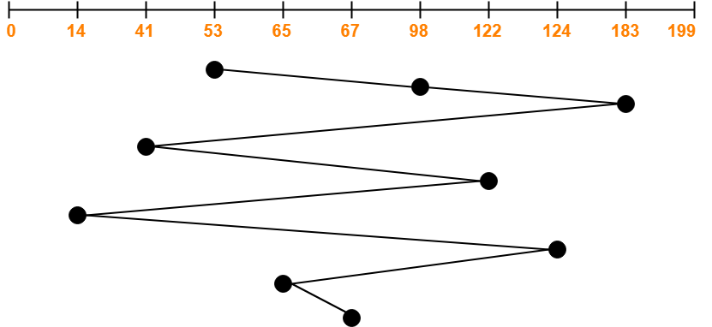

Total head movements incurred while servicing these requests

= (98 – 53) + (183 – 98) + (183 – 41) + (122 – 41) + (122 – 14) + (124 – 14) + (124 – 65) + (67 – 65)

= 45 + 85 + 142 + 81 + 108 + 110 + 59 + 2